**Date: 01/04/2024**

**DEPLOY HTML APPLICATION USING JENKINS PIPELINE:**

**PREQUISITES:**

1. **Install Jenkins in One Ec2 Server: (Jenkins Master)**

yum update -y

yum install java-17 -y

yum install git -y

yum install mvn -y

yum install docker -y

systemctl start docker

systemctl enable docker

systemctl status docker

docker run -d -p 8080:8080 -p 50000:50000 jenkins/jenkins:lts

1. **For Jenkins Slave:**

yum update -y

yum install java-17 -y

yum install git -y

yum install mvn -y

**Run Below Commands to connect Jenkins-slave with Jenkins-Master:**

java -jar agent.jar -url http://54.152.5.61:8080/ -secret 12fa91f4004e91707899d75b576ae1e722994b73ec7fe3ee89d60dff88e19996 -name "slave-1" -workDir "/home/ec2-user/"

1. **Install Application Server in Another Ec2 Machine :**

yum update -y

yum install httpd -y

service httpd start

service httpd status

chmod 777 /var/www/html/

1. **Required Plugins:**
2. Git hub
3. Publish Over SSH
4. **Configuration Details:**
5. Go to Dashboard -Manage jenkins – system
6. Scroll Down – Click on **Publish over SSH**
7. **Add ssh servers**

Name : Application Server

Hostname: Private Ip of Application Server ( Tomcat Server)

Username: ec2-user

Remote Directory: /var/www/html/

Click on Advance

Click on **Use password authentication, or use a different key**

Key : Paste Private Pem key of Application Server

Click on Test

It shows success message

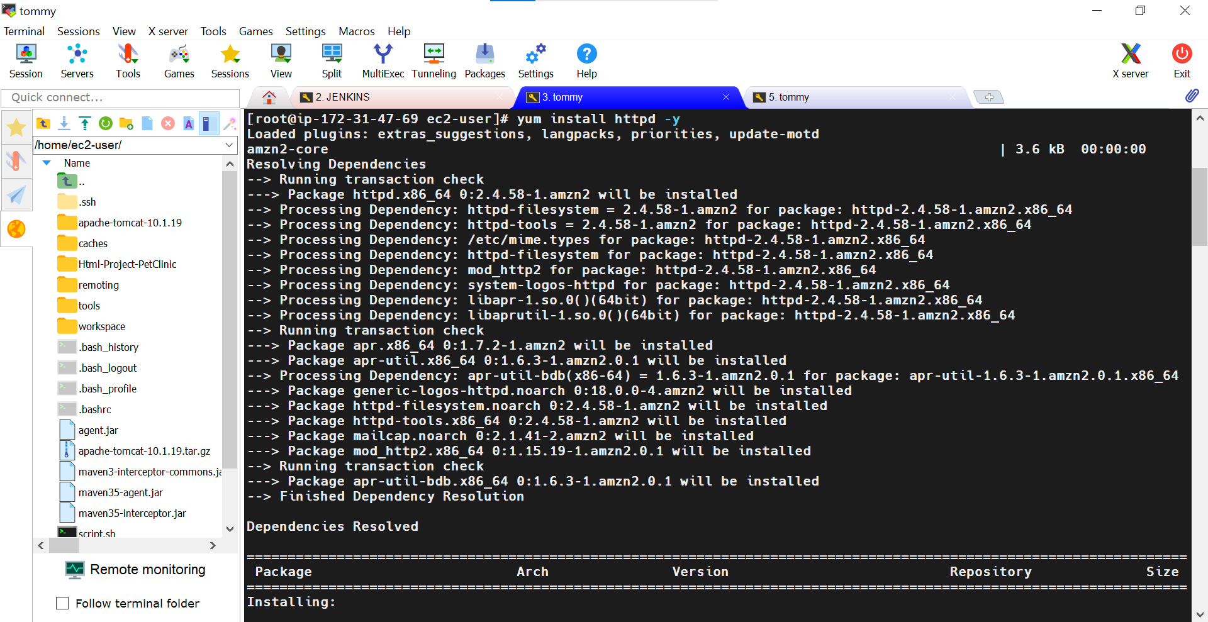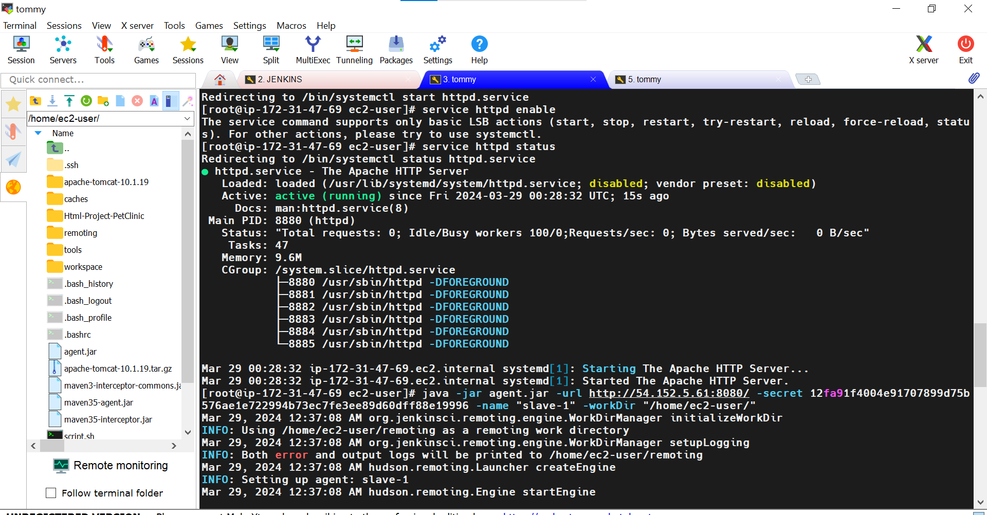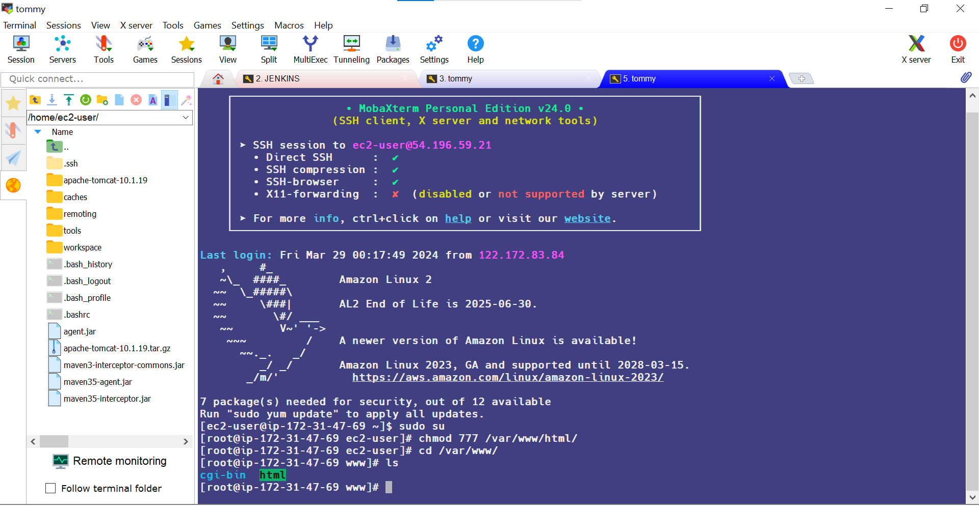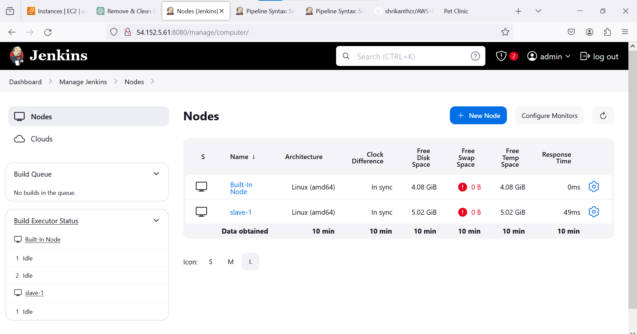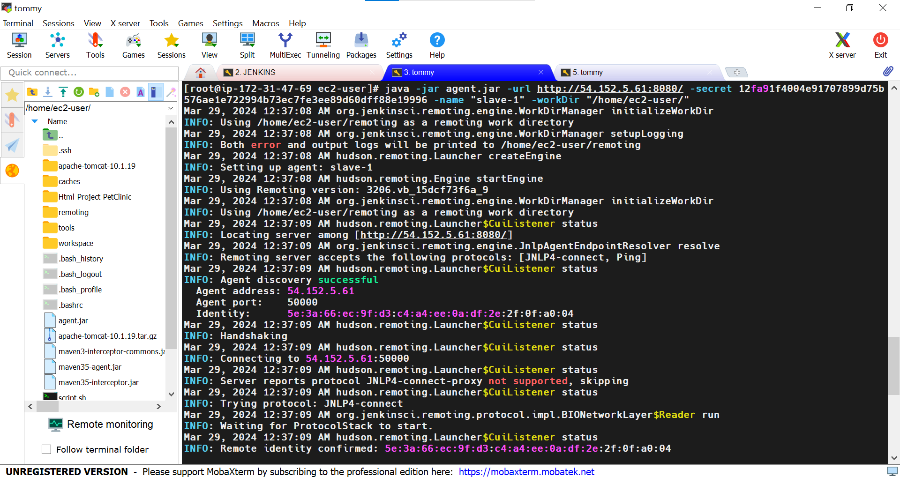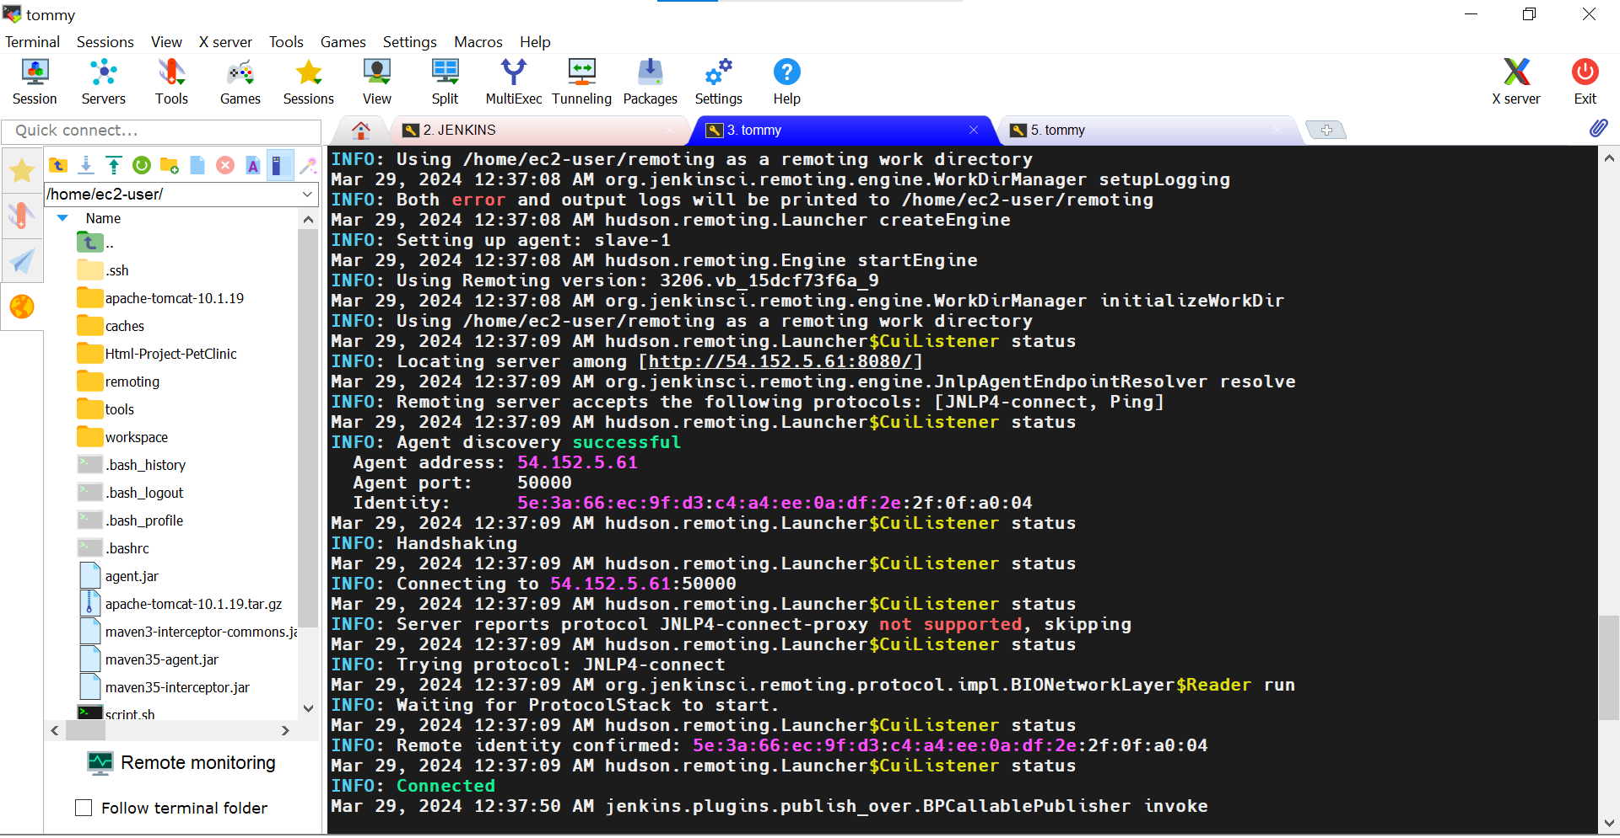

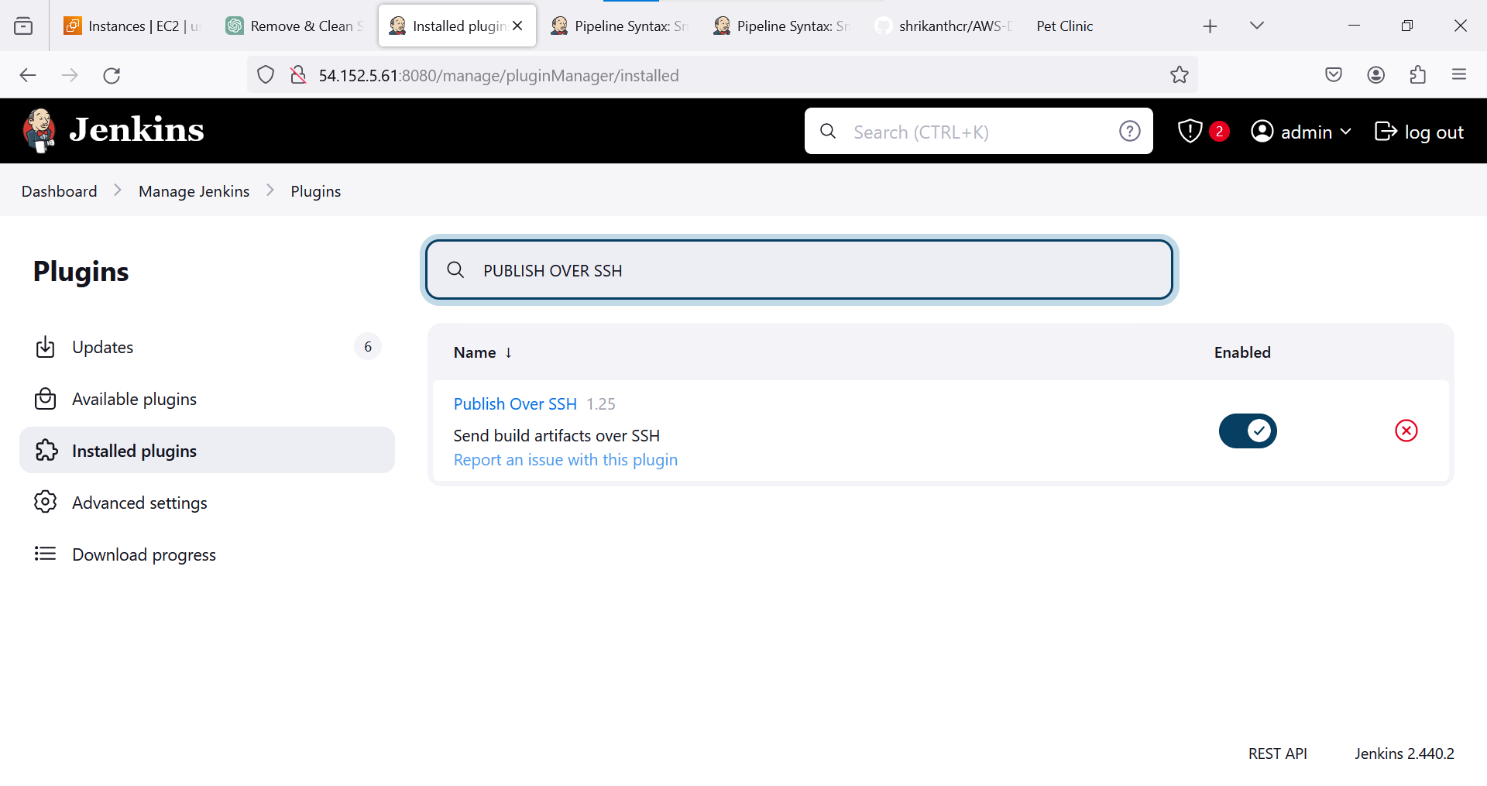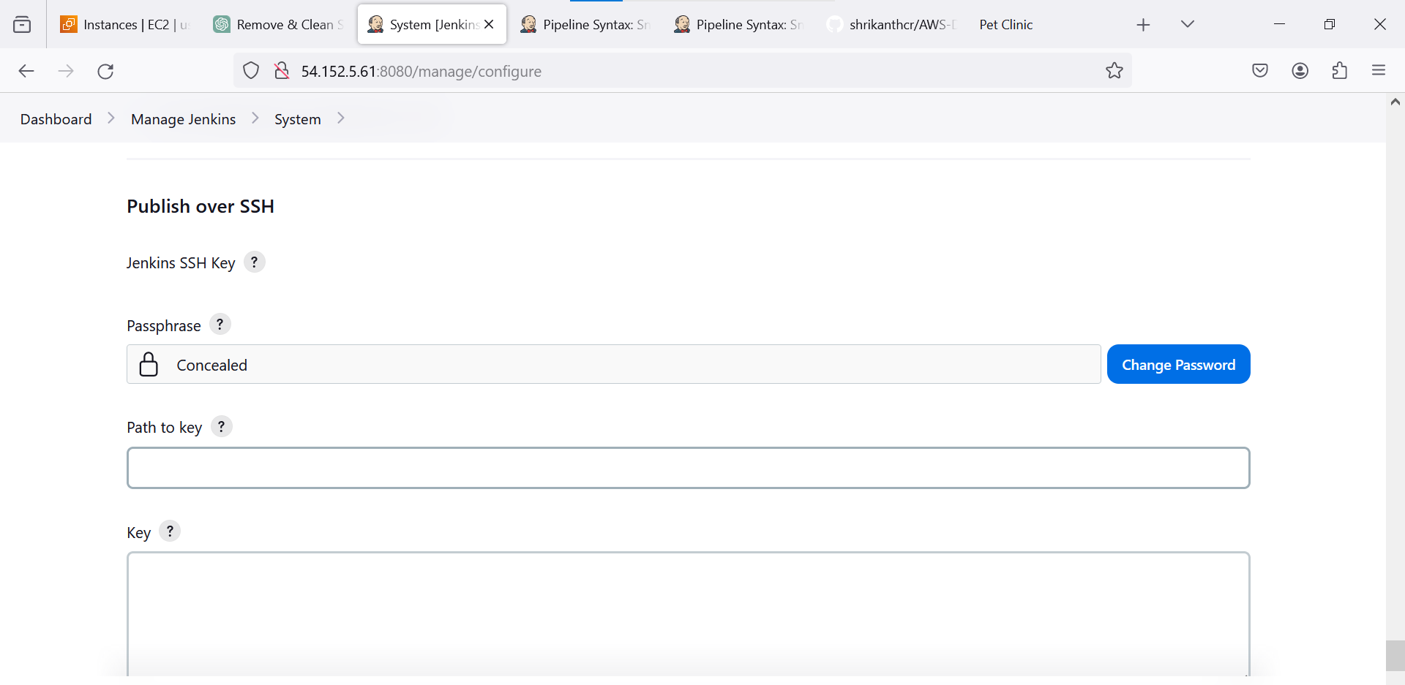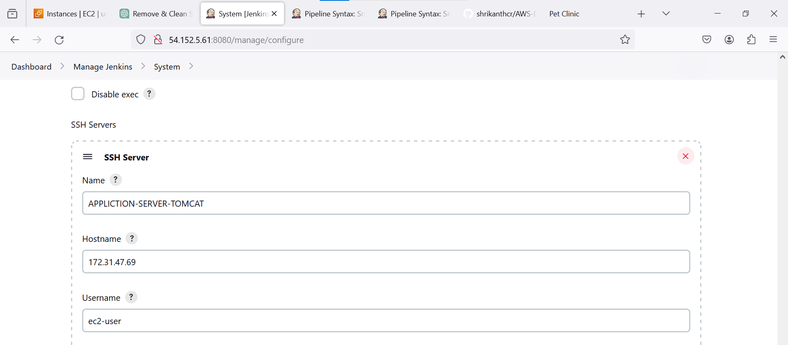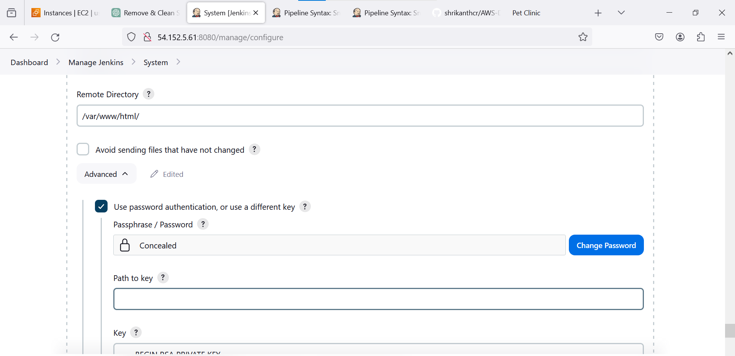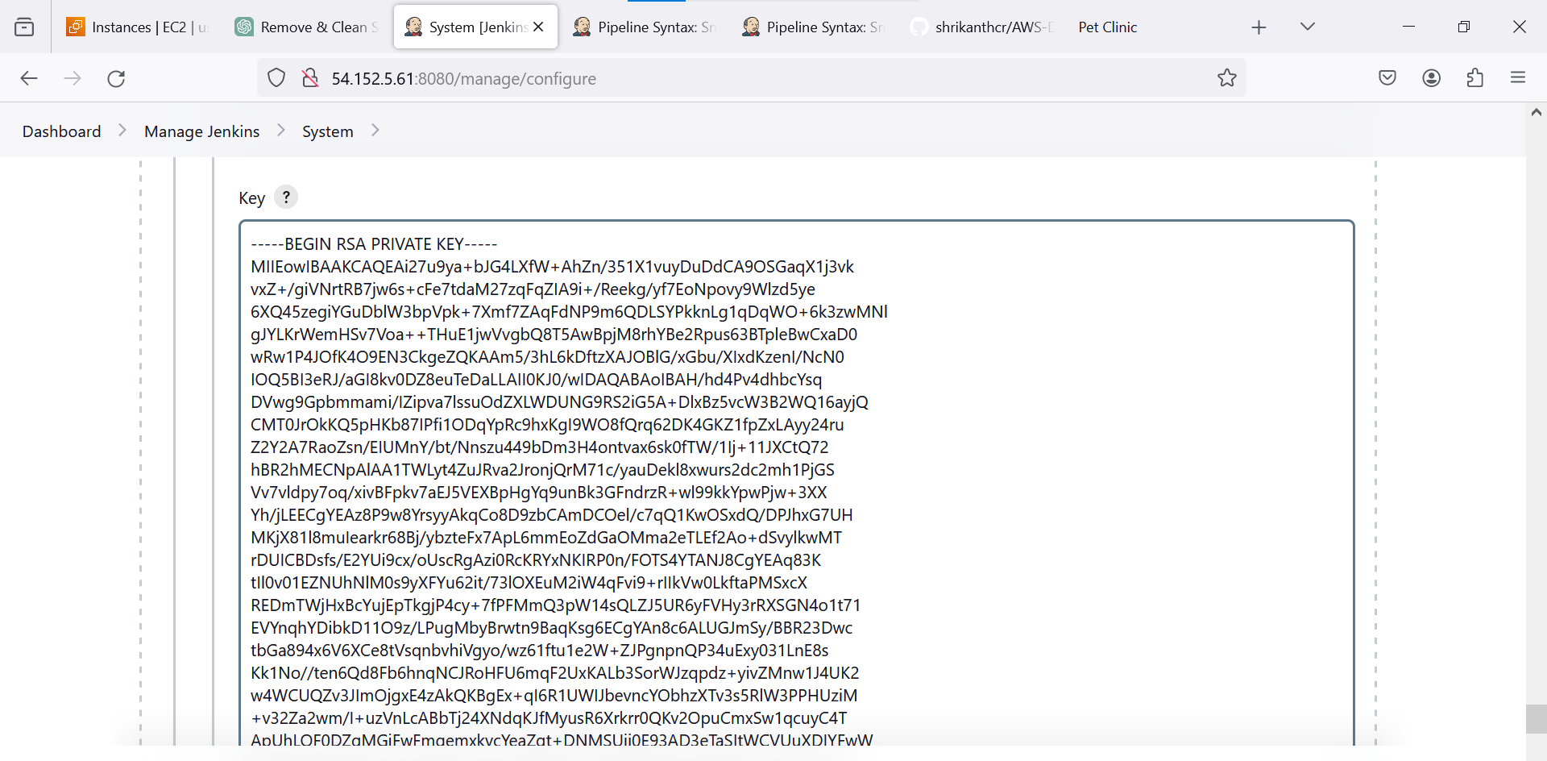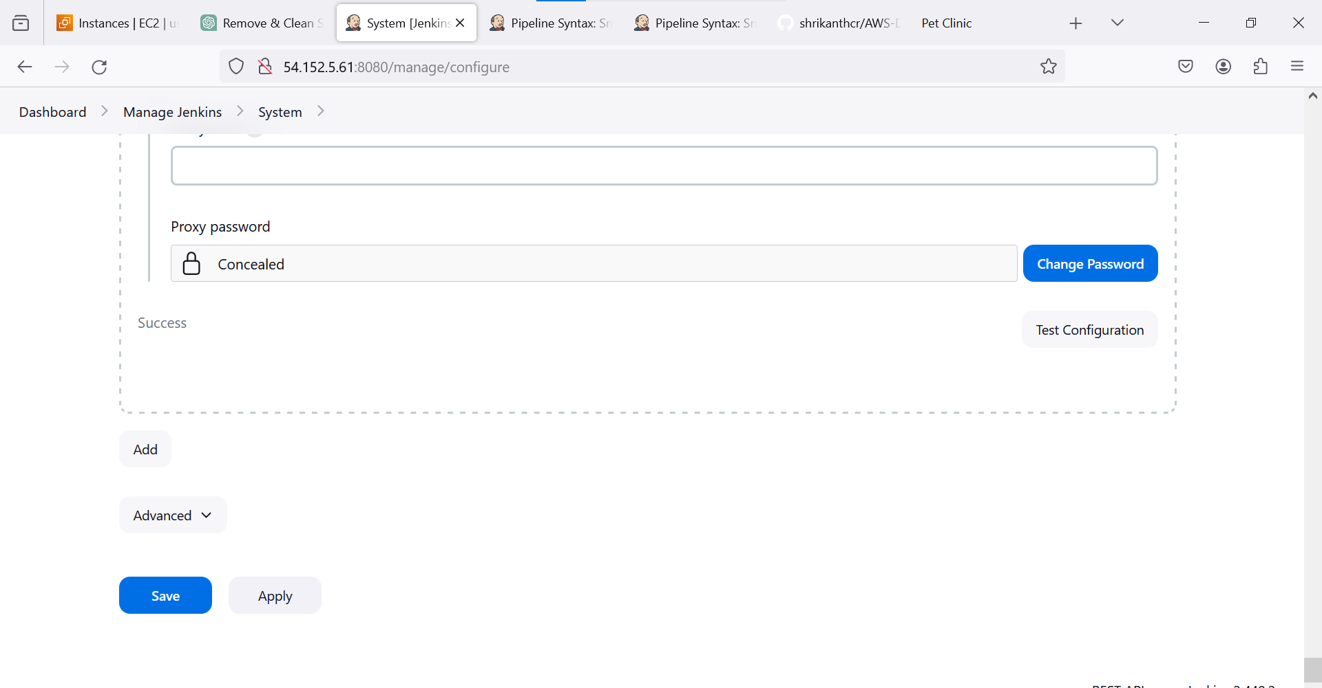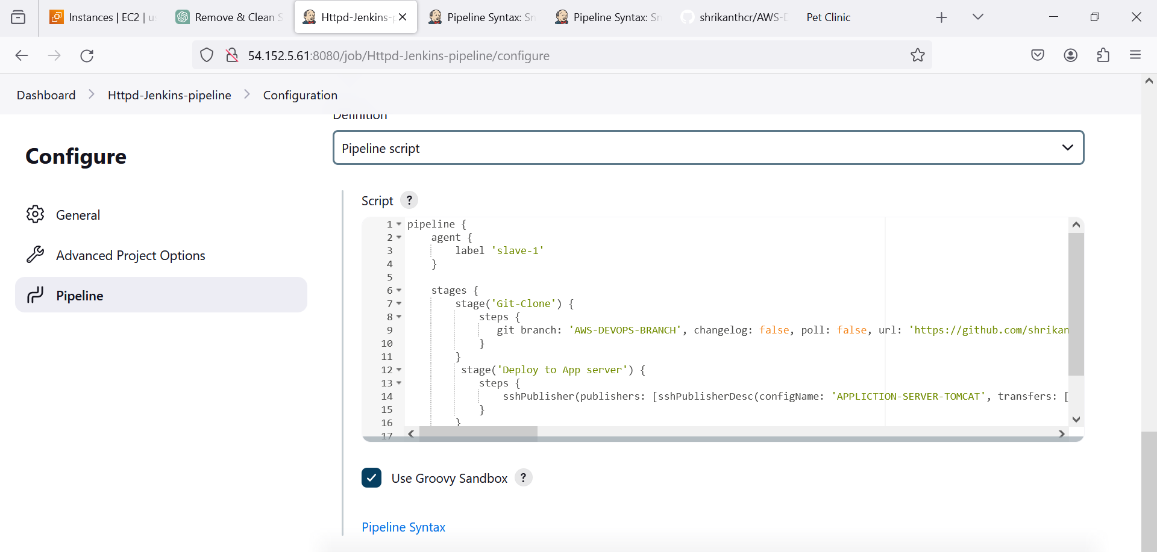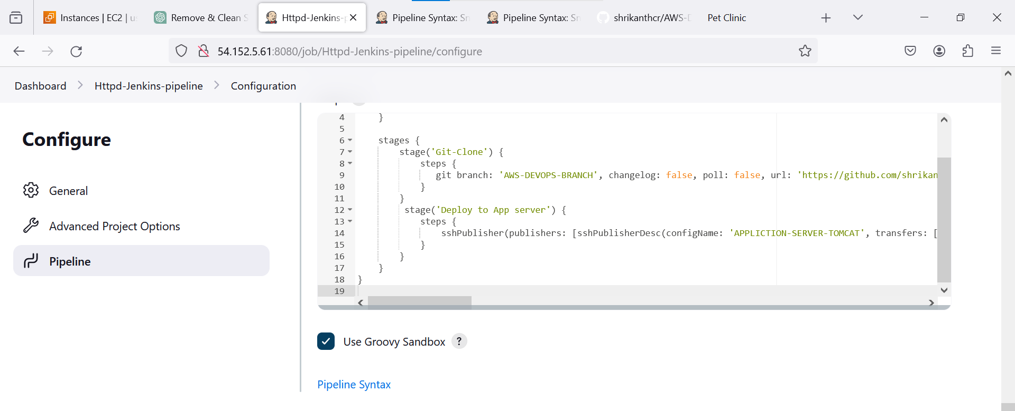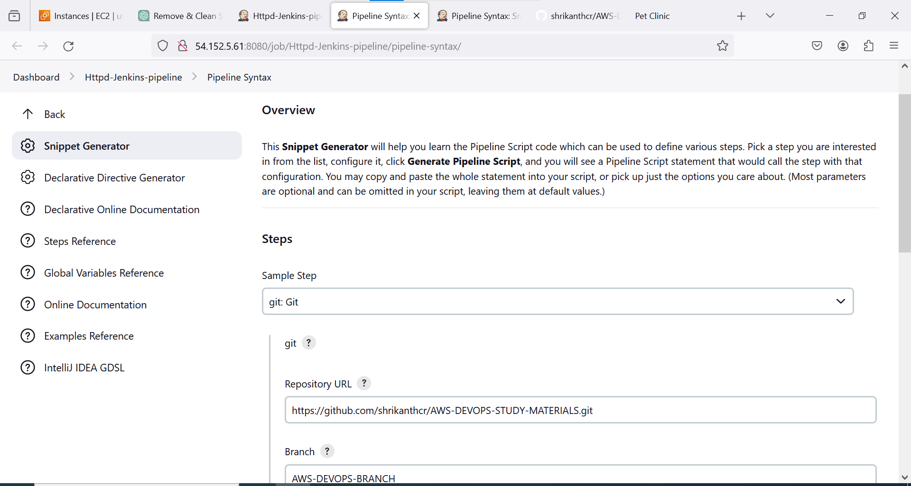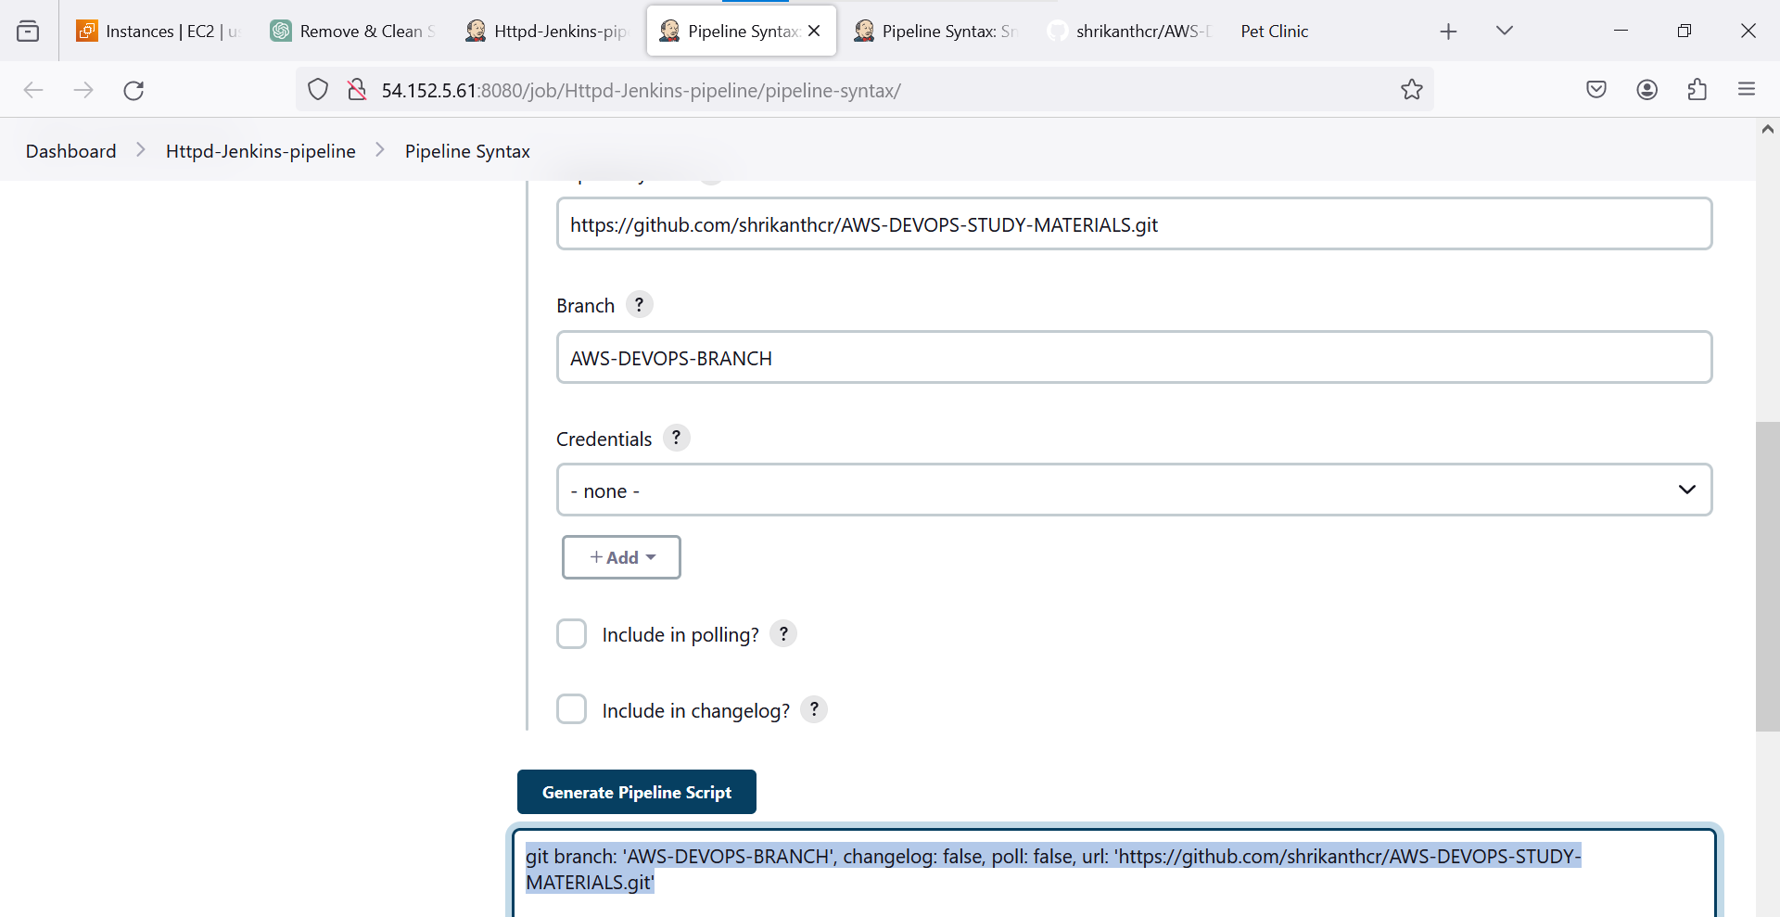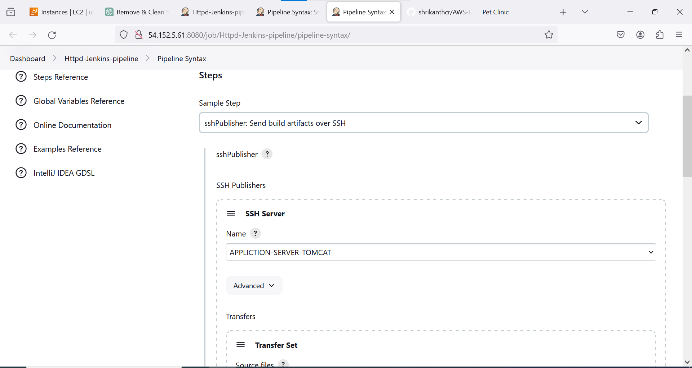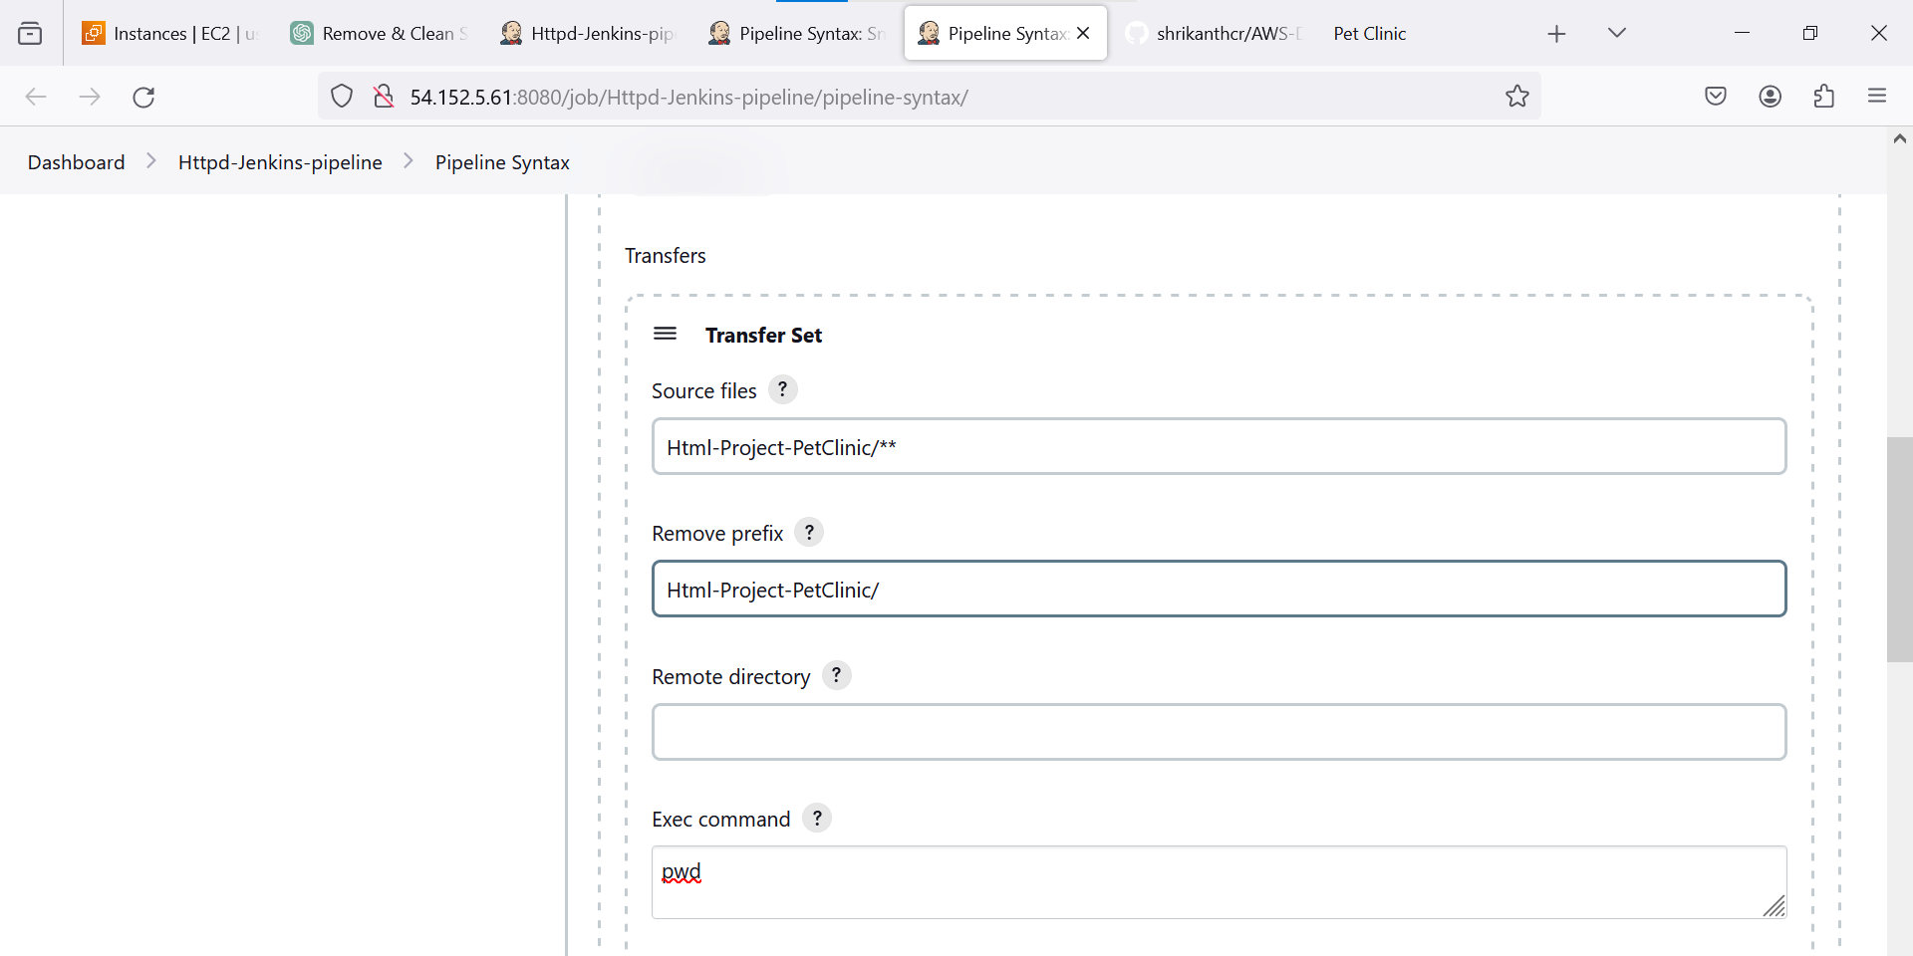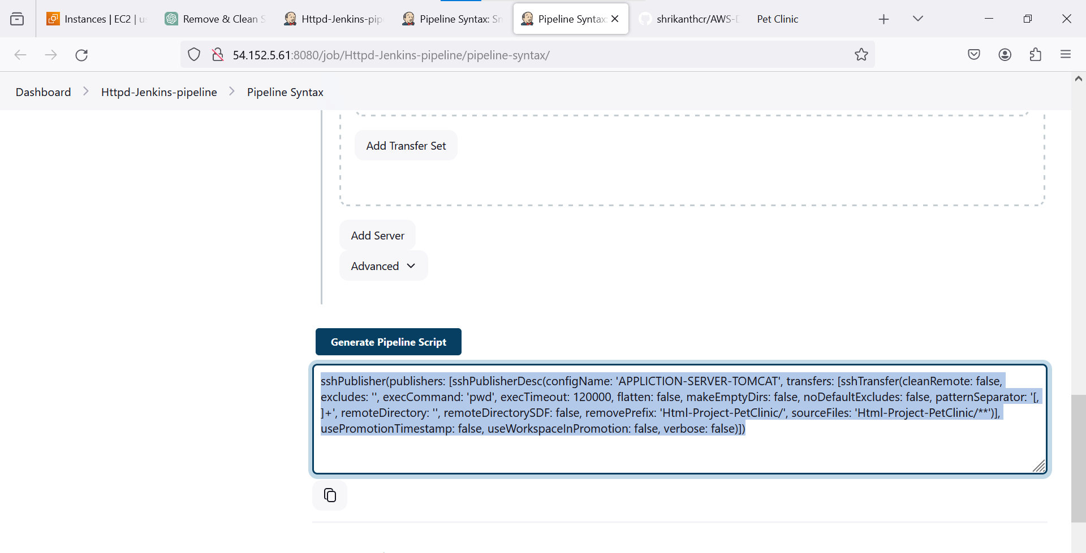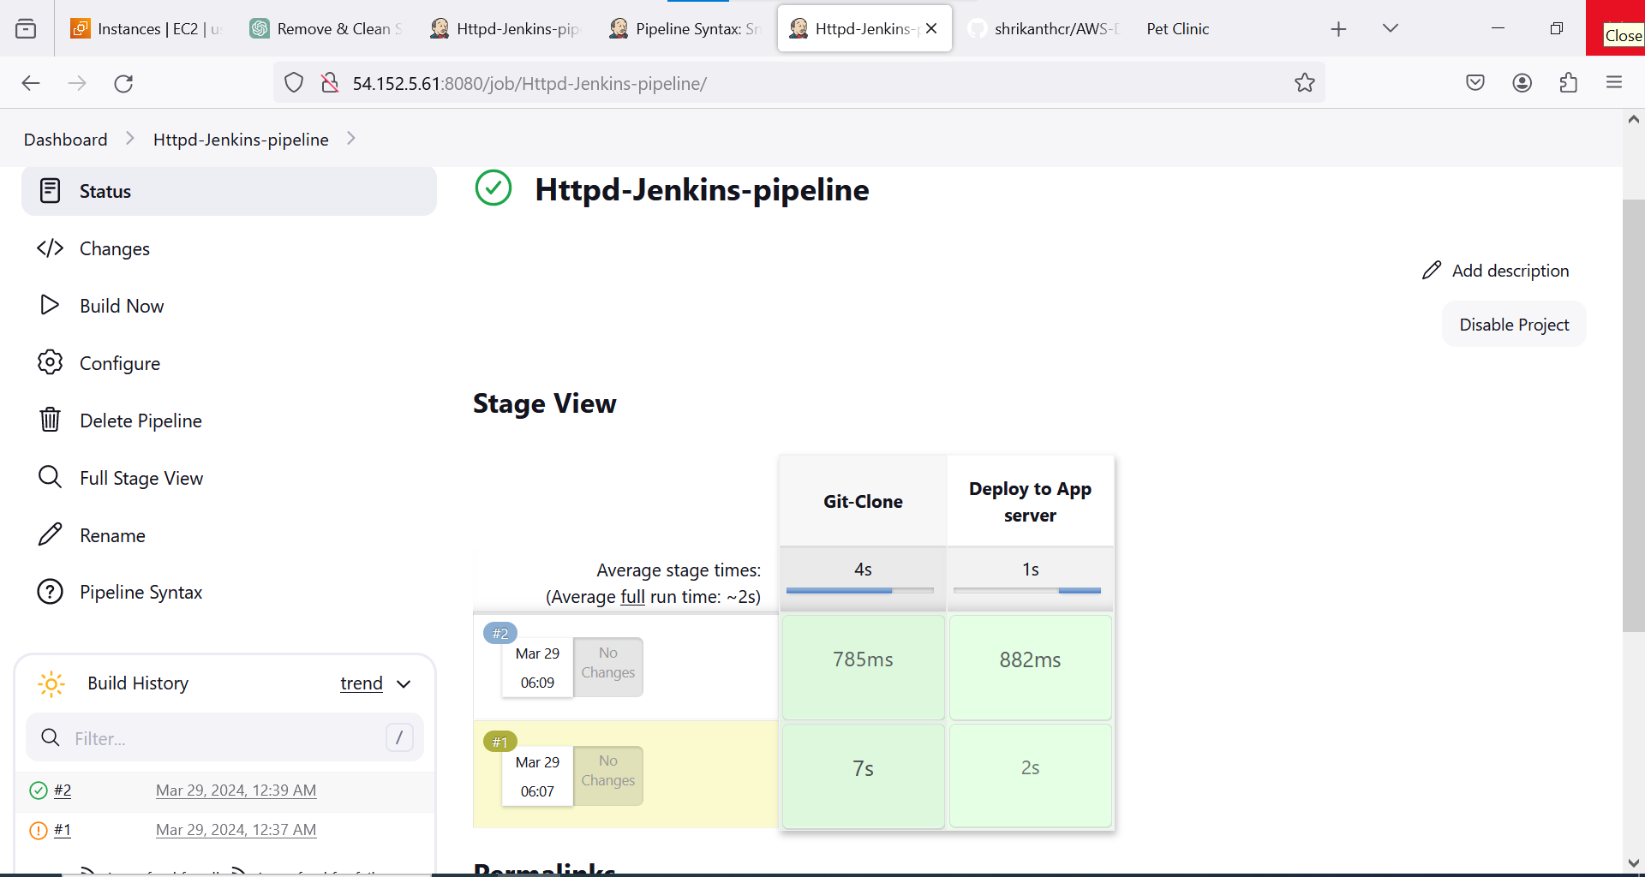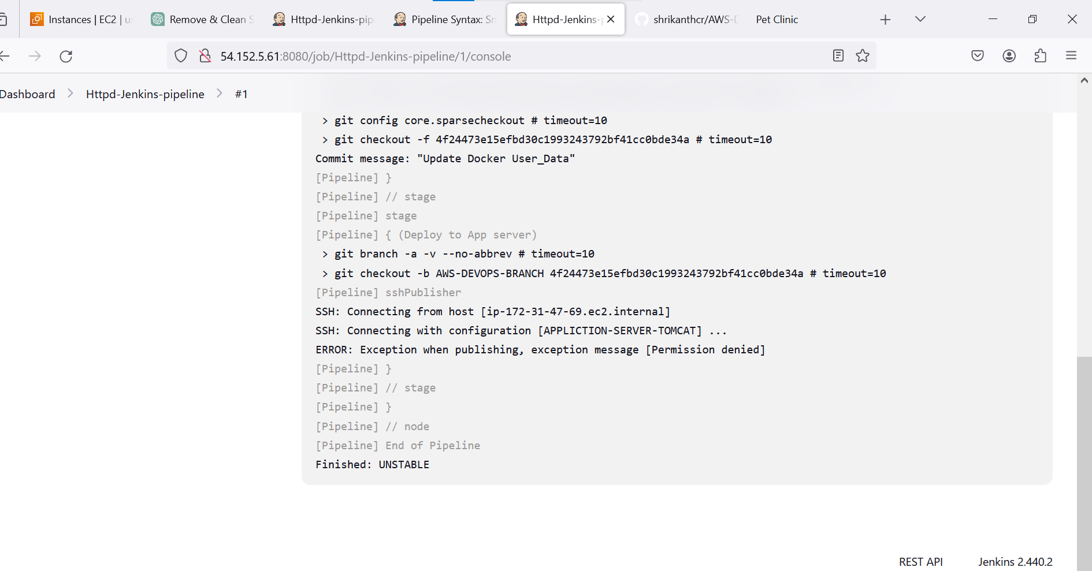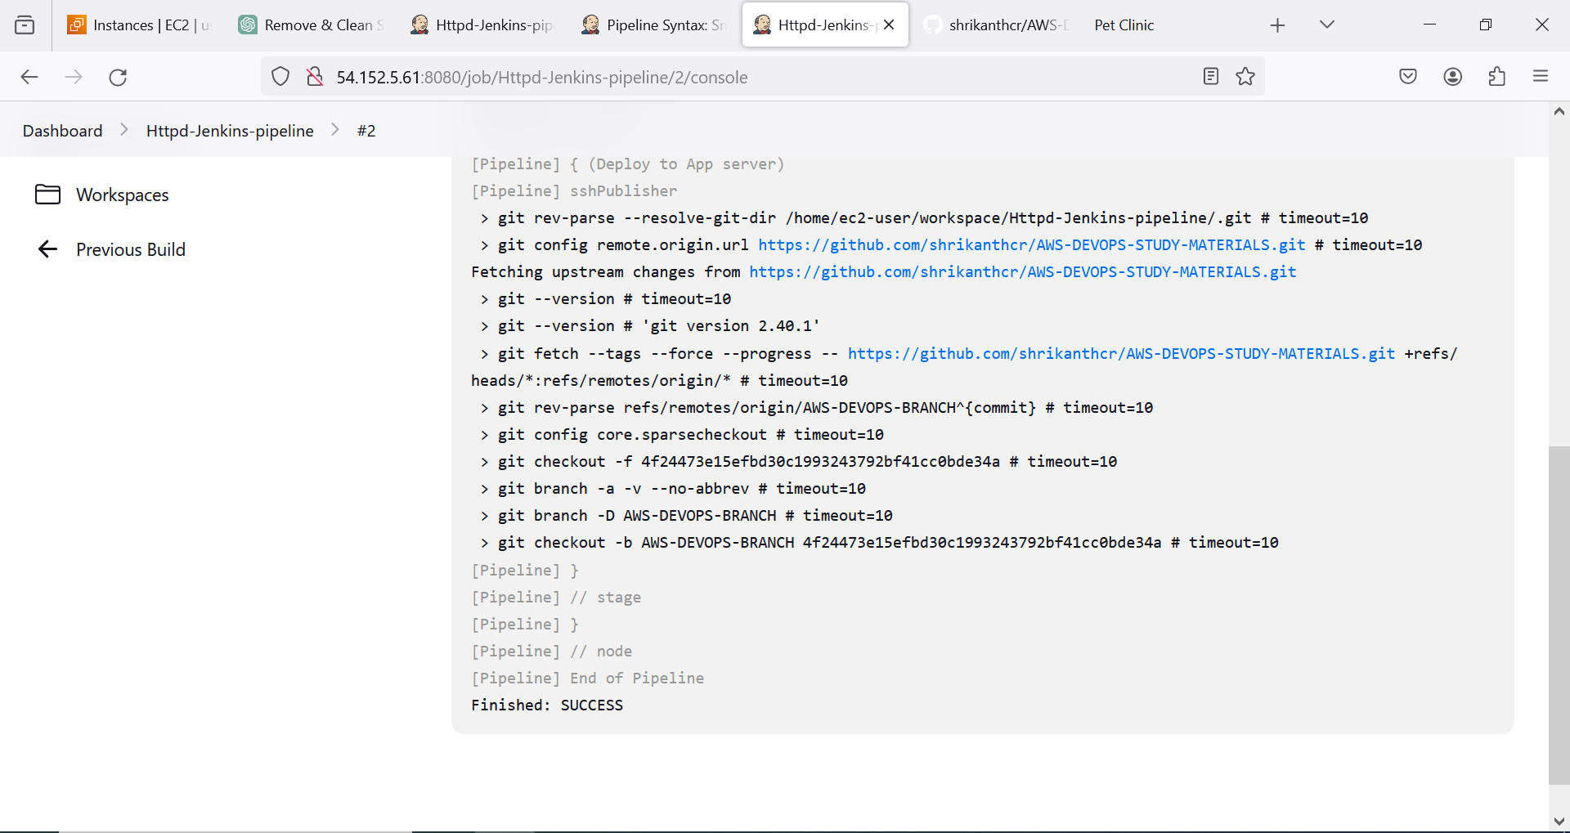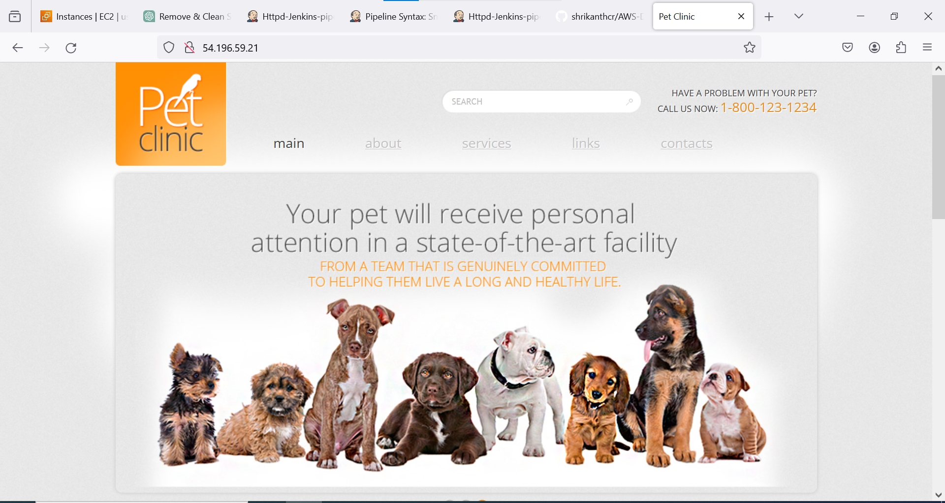

Private Ip of Tomcat Server (Application Server)

Paste Private Pem key pair Of Tomcat Server(Application Server)

**JENKINS-PIPELINE:**

pipeline {

agent {

label 'slave-1'

}

stages {

stage('Git-Clone') {

steps {

git branch: 'AWS-DEVOPS-BRANCH', changelog: false, poll: false, url: 'https://github.com/shrikanthcr/AWS-DEVOPS-STUDY-MATERIALS.git'

}

}

stage('Deploy to App server') {

steps {

sshPublisher(publishers: [sshPublisherDesc(configName: 'APPLICTION-SERVER-TOMCAT', transfers: [sshTransfer(cleanRemote: false, excludes: '', execCommand: 'pwd', execTimeout: 120000, flatten: false, makeEmptyDirs: false, noDefaultExcludes: false, patternSeparator: '[, ]+', remoteDirectory: '', remoteDirectorySDF: false, removePrefix: 'Html-Project-PetClinic/', sourceFiles: 'Html-Project-PetClinic/**')], usePromotionTimestamp: false, useWorkspaceInPromotion: false, verbose: false)])

}

}

}

}